 | YEAR 12 MATHEMATICS SPECIALIST  SEMESTER ONE 2017  TEST 2: Functions

Name: _______________________
Monday 3rd April
Time: 50 minutes Mark /40 = %

- Answer all questions neatly in the spaces provided. Show all working.
- You are permitted to use the Formula Sheet in both sections of the test.
- You are permitted one A4 page (one side) of notes in the calculator assumed section.

Calculator free section Suggested time: 30 minutes /26

- [9 marks]

Two functions f and g are defined by and

  - Express in terms of x

[1]
  - What is the natural domain of

[2]
  - What is the range (co-domain) of

[2]
A third function is such that .
  - Express in terms of x.

[1]
  - Clearly define and specify both its domain and range.

[3]

- [7 marks]

  - Solve the inequality

[3]
  - Calculate where the line intersects and illustrate your solution on the axes provided.

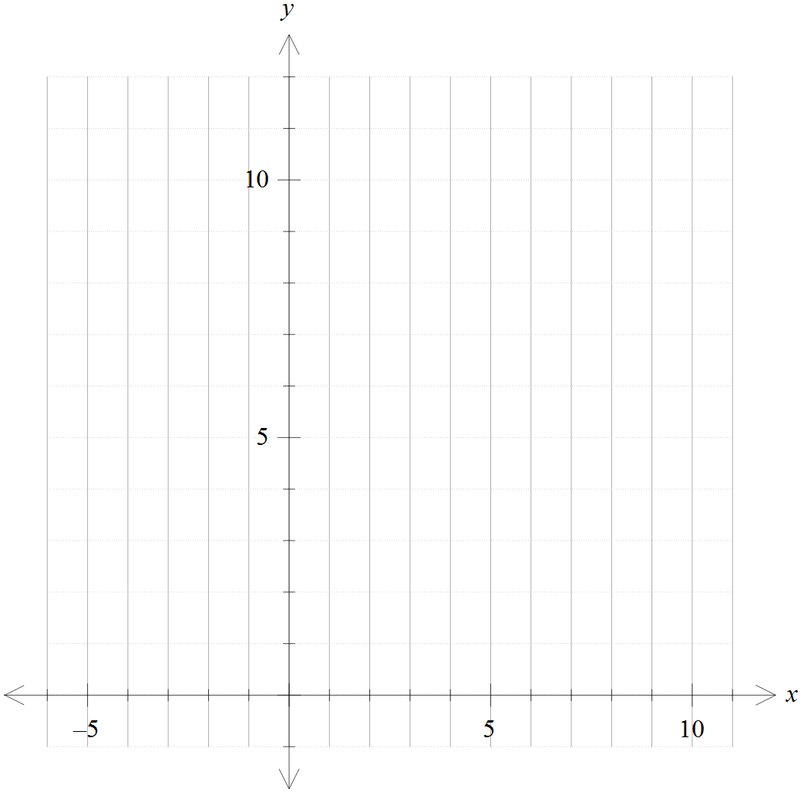

[4]

- [10 marks]

The function is represented by the graph of shown on each set of axes provided.

  - 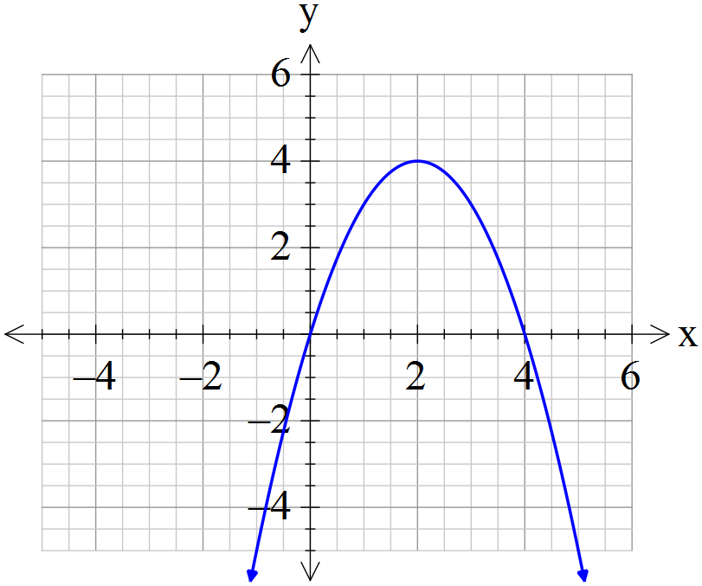Draw , and on these separate diagrams:


[4]

The domain of is restricted to so that can be defined as a function.

  - Determine the largest possible value of k
[1]

  - Define and specify its domain and range.
[5]

Calculator assumed section Suggested time: 20 minutes /14
Name: _______________________
- 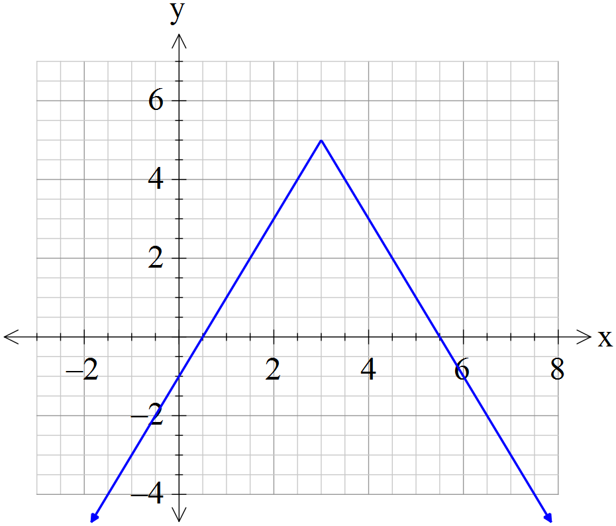[7 marks]
The graph of for has a y-intercept of and a maximum point at , as shown.

  - Evaluate a, b and c.
[3]

  - For which value(s) of d does have exactly four solutions?

[2]

  - Add a graph of to the axes above so that

[2]

- [7 marks]
This graph represents a function of the form
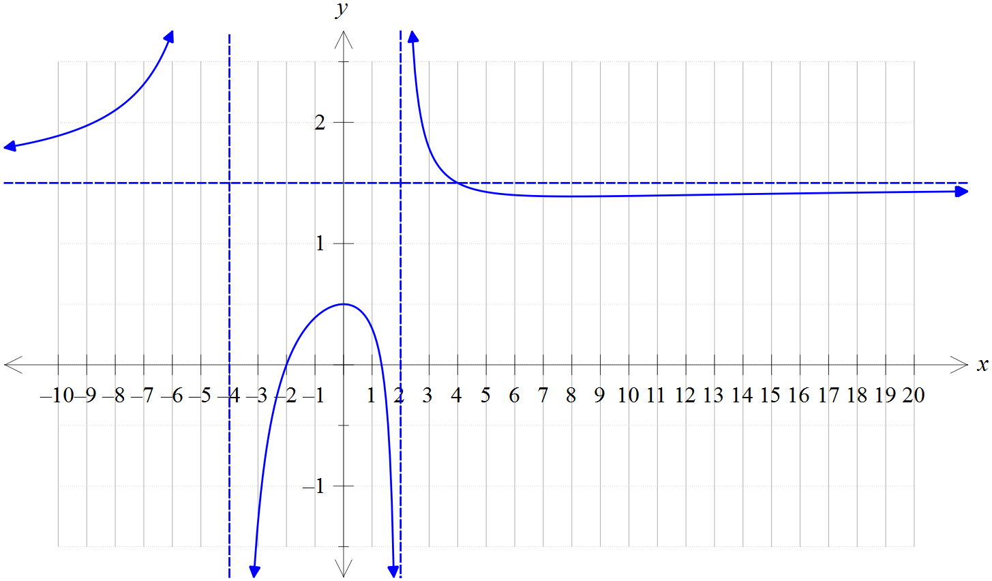
The asymptotes are as shown and the unmarked x intercept is .
        - Determine the values of the constants a, b, c and d.

[4]

        - What is the exact range of ?
[3]

